Task on VPC-2

- Create one VPC, with 1 public subnet and 1 private subnet.
AWS Console → VPC → Your VPCs → Create VPC
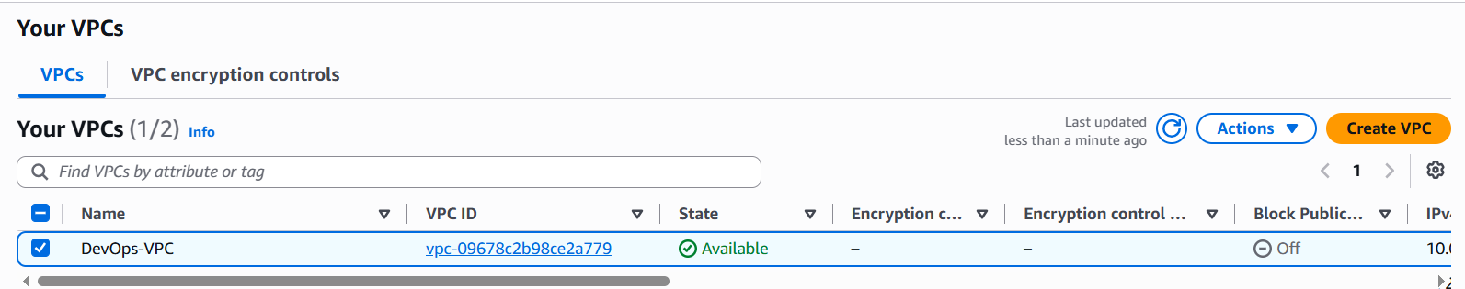
Enabled DNS resolution and Hostnames
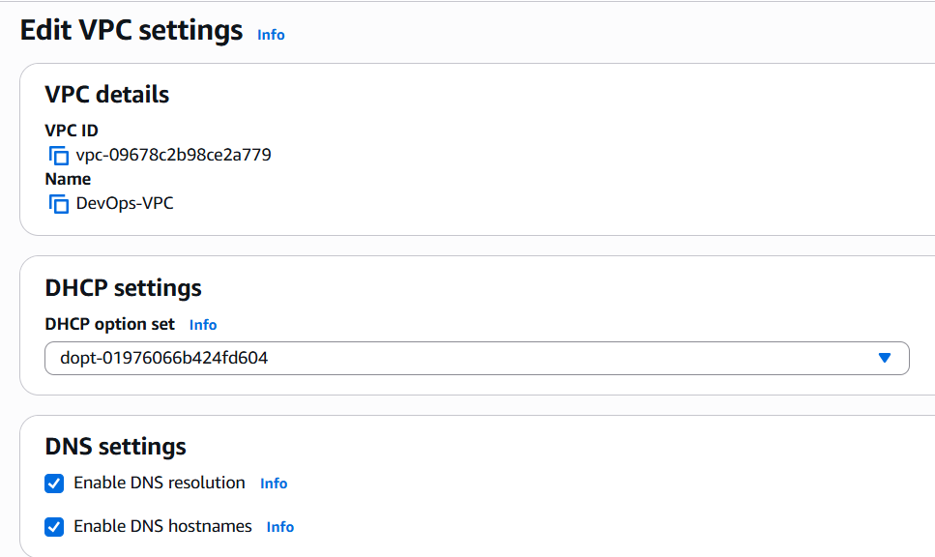
Created the subnets
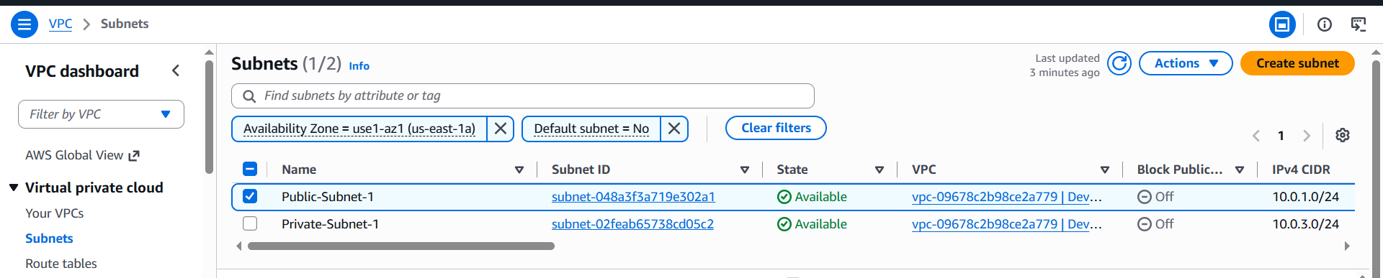
Enabled auto assign settings
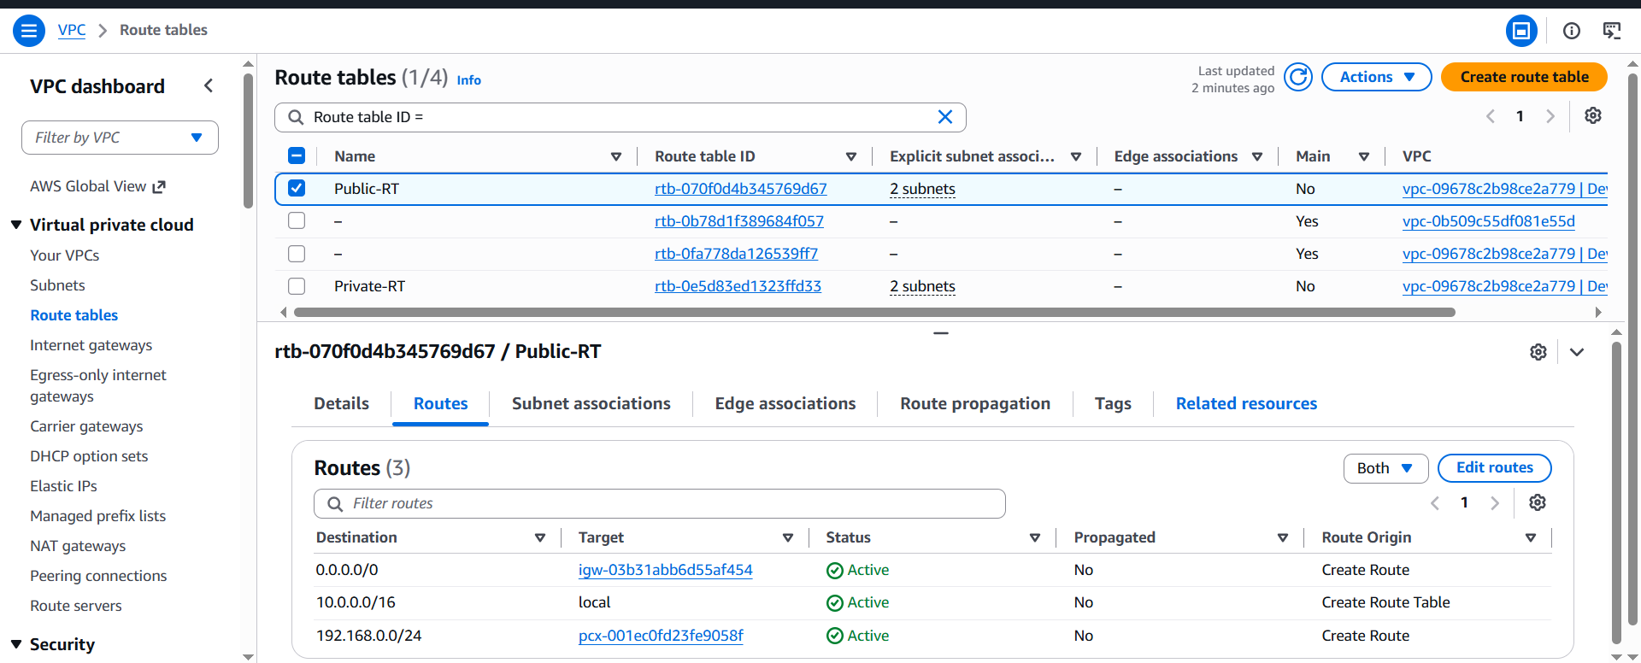
Created Route tables
- Enable VPC peering for cross-region.
Created the VPC in other Region
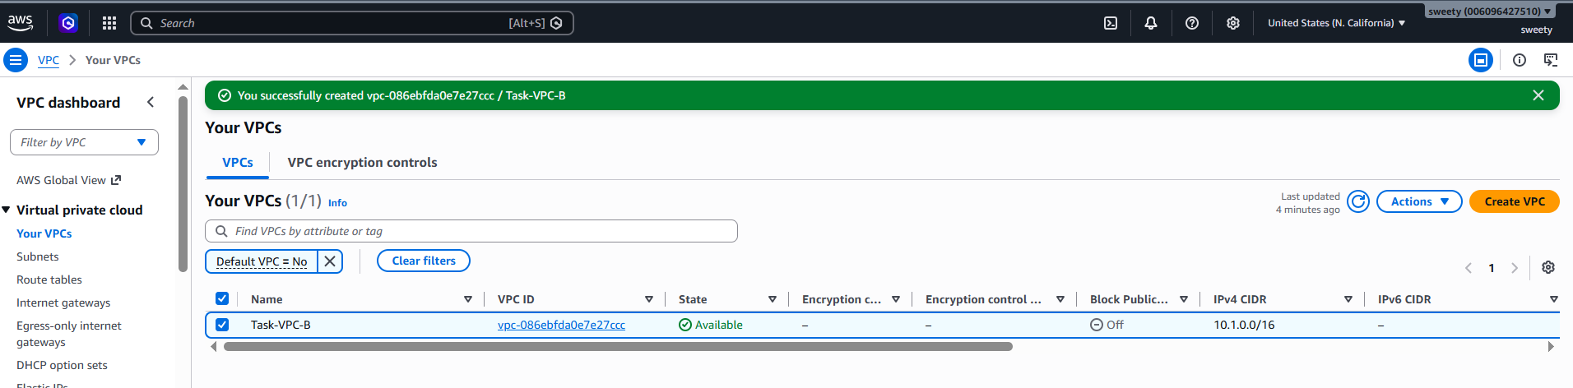
Create peering: VPC → Peering connections → Create peering connection
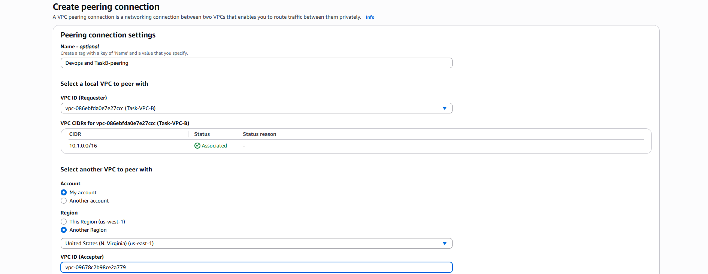
Requested from one zone and accepted the peering request from other region
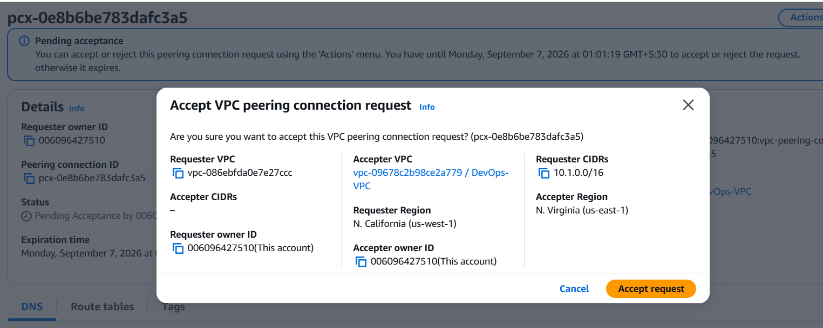
Created the Route tables

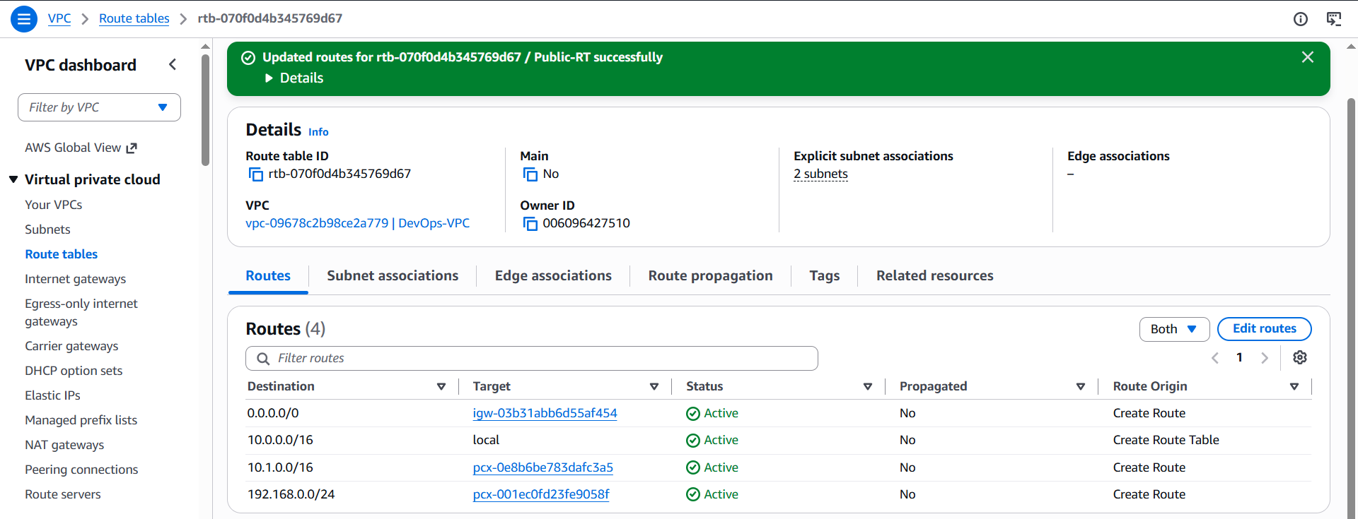

- Enable VPC peering for cross-account (you can collaborate with your friend to do this task).
Step 1: Create/identify the VPCs
I used an existing VPC in my AWS account
My VPC CIDR: 10.0.0.0/16
My VPC ID: vpc-09678c2b98ce2a779
Important: The CIDR blocks of the two VPCs must not overlap.
Step 2: Create VPC Peering Connection
1. Open AWS Console.
2. Go to VPC.
3. Select Peering connections.
Step 3: Accept the Peering Request
My friend logged into their AWS account.
1. Go to VPC → Peering connections.
2. Select the pending peering request.
3. Click Actions.
4. Select Accept request.
5. Confirm the acceptance.
After acceptance, the peering connection status changed to: Active
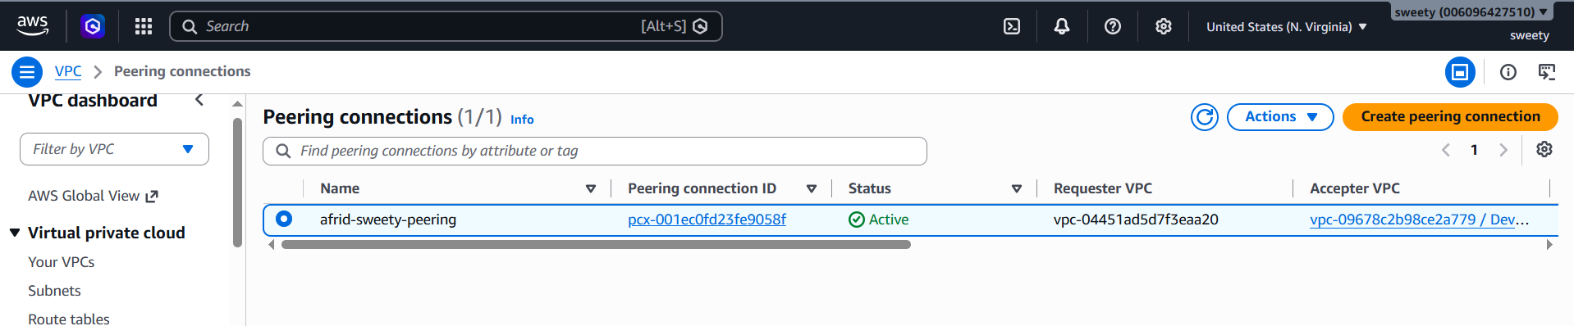
Step 4: Add Route in My VPC
In my AWS account:
1. Go to VPC → Route tables.
2. Select the route table associated with the subnet that needs communication with the friend's VPC.
3. Select Routes.
4. Click Edit routes.
5. Click Add route.
6. Enter my friend's VPC CIDR as the destination.
Step 5: Add Reverse Route in Friend's VPC
My friend needs to add a route back to my VPC.
In my friend's AWS account:
1. Go to VPC → Route tables.
2. Select the appropriate route table.
3. Go to Routes → Edit routes.
4. Add a route to my VPC CIDR.
5. Select the same VPC peering connection as the target.
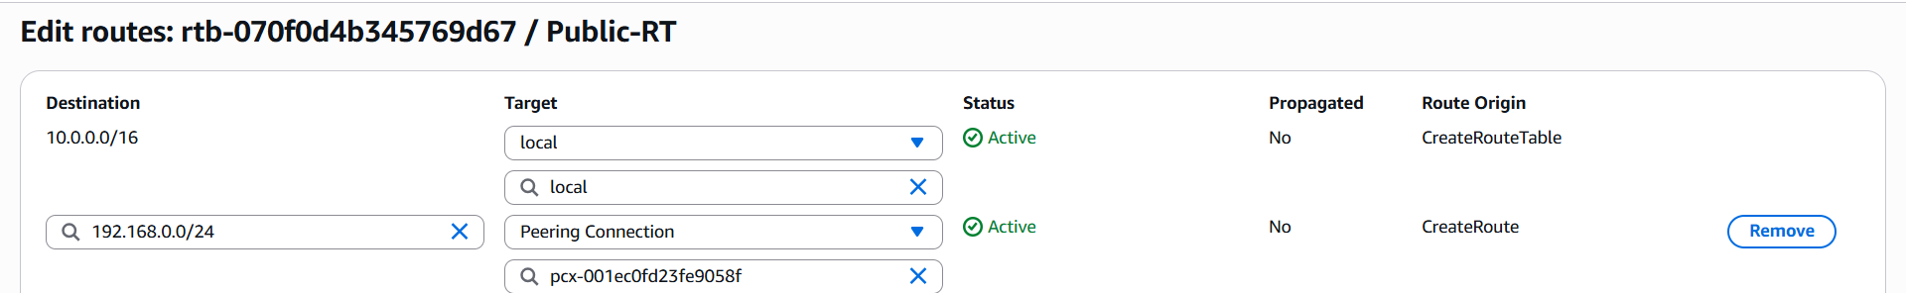
- Set up a VPC Transit Gateway.
AWS Console → VPC → Transit Gateways → Create transit gateway
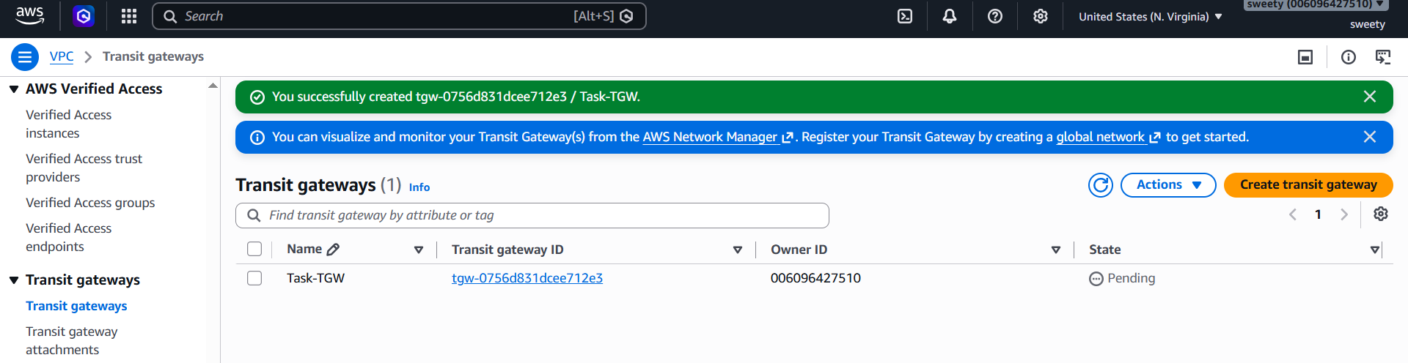
Step 2: Create Transit Gateway Attachment
Go:
VPC → Transit Gateway Attachments → Create transit gateway attachment
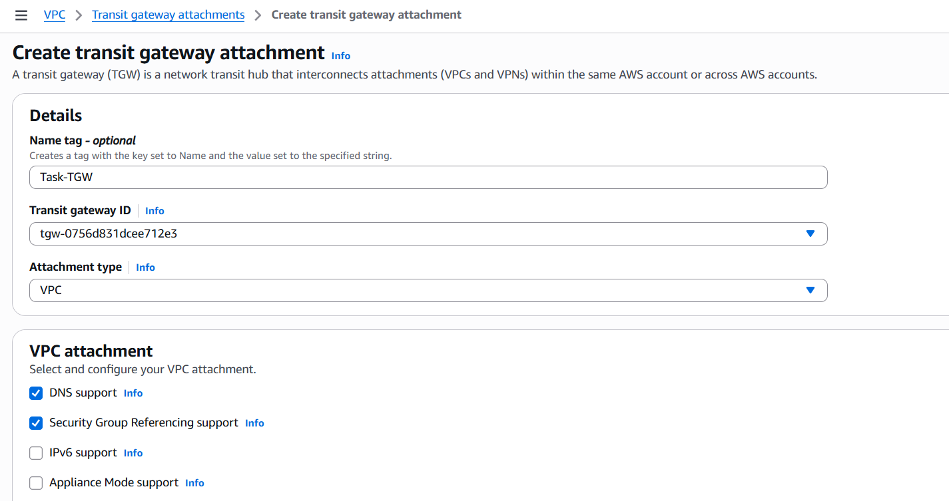
Step 3: Verify TGW route table
Go:
VPC → Transit Gateway Route Tables
Open the TGW route table.
You should see the VPC attachment associated/propagated depending on the configuration.
For a more complete demonstration, we can attach another VPC later and route traffic through the TGW.
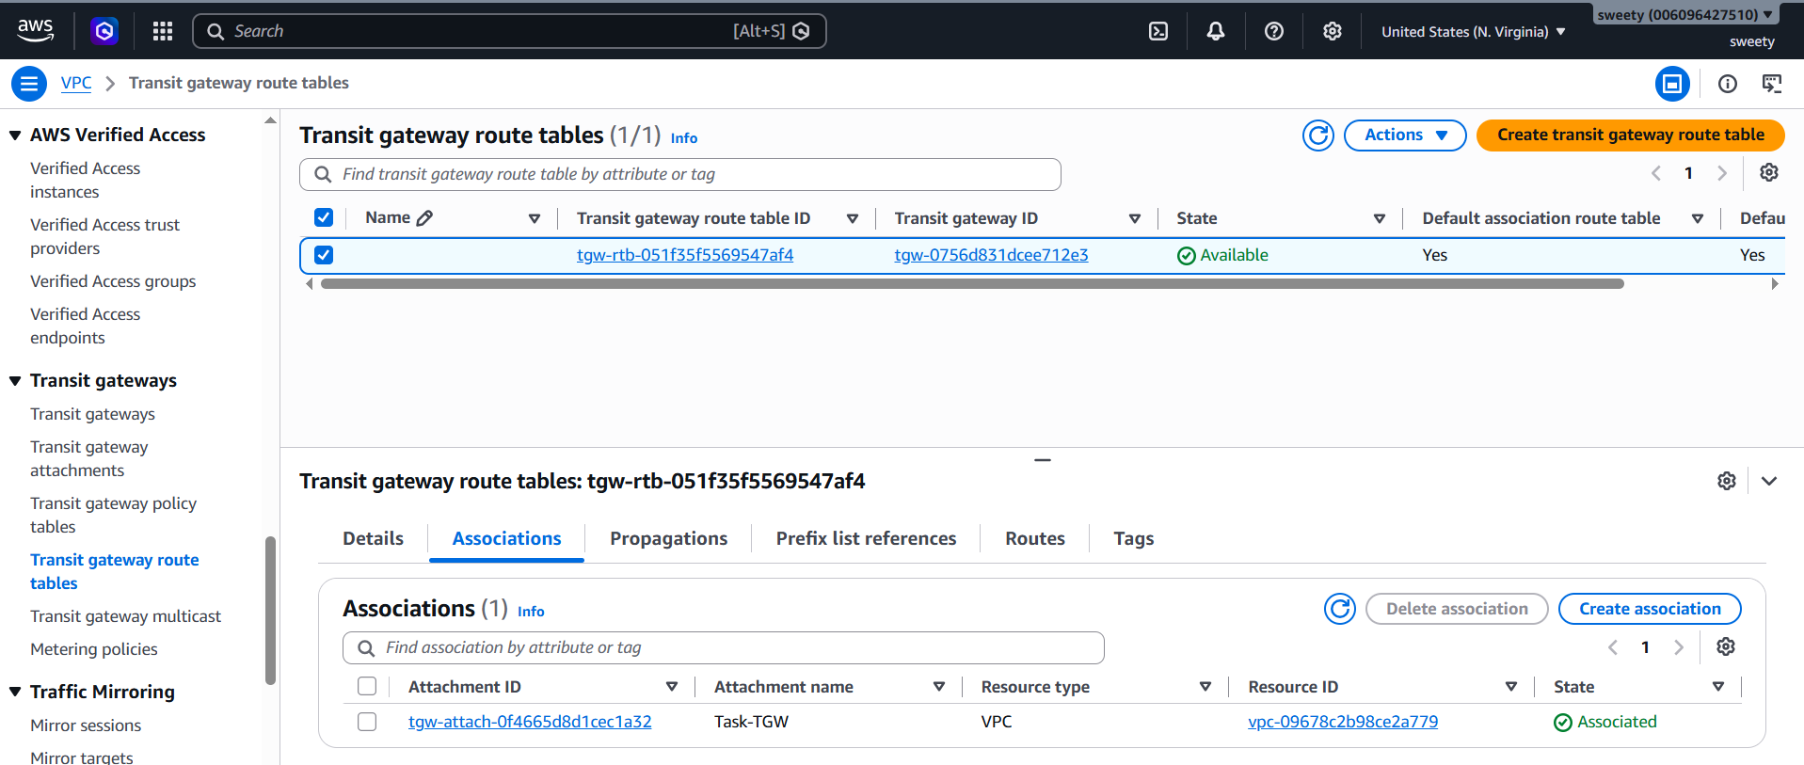

- Set up a VPC Endpoint.
Steps
1. Go to VPC → Endpoints.
2. Click Create endpoint.
3. Enter name:
Task5-S3-Endpoint
4. Select AWS services.
5. Select:
com.amazonaws.us-east-1.s3
6. Choose Gateway type.
7. Select VPC:
Today-Task-VPC
8. Select the appropriate route table.
9. Click Create endpoint.
10. Verify the endpoint is successfully created.
Endpoint :
vpce-05131cfc9d72007b2
